**Chapter 9**

*System development lifecycle*

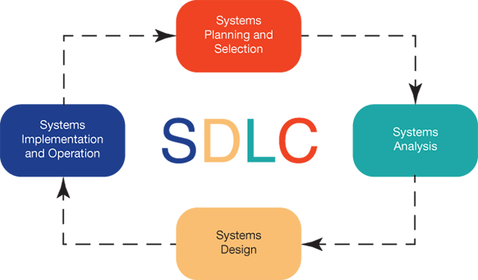

As demonstrated in the diagram above, the system development lifecycle is broken down into 4 phases from the beginning to the end of the cycle. These cycles move from planning and selection to system analysis then to system design. Finally, the cycle ends at the system implementation and operation. 3

*Phase one: Systems planning and selecting*

In the beginning of the system development lifecycle, we have the systems planning and selection. It is important to identify the different types of projects available. Since this system only works with one project at a time, identifying and selecting the best project that will enable the organizational goals is crucial in decision making. Once the project is selected, planning on how this protect will move forward is the next step. This is relatable to the motion picture and production industry, since many ideas for movie production will make its’ way into the lineup. As a result, it is important to evaluate all the possible outcomes.3 The one possible outcome that yield the best possible product is the movie that will be ready for production. Before it advances into production, a well-established plan is needed in establishing how to move forward. This system can also be implied once the production is complete such as when edits and special effects are being integrated in the film. A perfect example that demonstrates this phase is the movie Avatar produced by James Cameron. This production has the largest gross revenue of 2.7 billion 1 in sales. This film took approximately ten years in the planning before Cameron felt that the technology was advanced enough to take the movie into production.2

*Phases two: system analysis*

Phase two consist of gathering data, analyzing the data and distributing the information obtained from that data. Analyst work closely with users, managers, customers and business processes to gather the needed information. Some of the techniques used to gather information include questionnaires, interviews, observations, document analysis or joint application design that consists of a group of people coming to gather to agree on system requirements.3 This relates to movie production because gathering data is extremely helpful when doing a film. For example, information on types of actors can be essential when figuring out the right cast for a movie. Knowing the likes and dislikes of customers by gathering questioners and even gathering data on songs to add affect to the movie’s scenes can be helpful in making a successful film. When producing Avatar, Cameron wanted to enhance the movements and facial expression of the avatar giving them a more realistic digital lifeform. Cameron worked with a group of artists to figure out how the they could accomplish this. To get the movements they film using motion-capture technology that had the capacity to record in a 360-degree angle allowing them to capture every move.1 They gathered data by filming the facial expressions up close to get a more accurate facial movements and expressions. These were then later digitally inputted to get a more realistic avatar. Without data movie production would be extremely difficult resulting in a low budget movie with hardly any success. Information systems are useful in production since it requires extensive data to be gathered when making a production, for instance Black Panther, produced by Kevin Feige, required data collection from the Marvel comic books, site location, music, well as gathering cultural data; they analysis that data and constructed it into the production.

*Phase three: system design*

The third phase, system design consists of building an information system. When constructing an information system using the processing and logic operation allows for raw data to be converted into new information.3 The new information can be constructed into structure charts, decision trees, programing code, pseudocode, flow charts which will eventually be converted into code.3 Another process is designing database and files. When designing a database, it is important to design it based on the needs of the organization. For example, in the movie industry a data base can be constructed for employees. This can be useful to track the number of employees, track the hours worked or their schedule.

*Phase four: implementation and operation*

The last phase, implementation and operation occurs when the information system is programed, installed, tested and supported.3 when testing for a system there are 3 different types of test that are conducted to insure the system is running properly. Development testing is conducted by programmers in which they check individual modules for errors. The next test is called the alfa testing were a software tester test the overall system to make sure its design is functionally accurately. The final test is called beta testing were users test the system using actual data to test the capabilities of the information system. When it comes to the motion picture and production industry this phase is equivalent to reviewing editing and making corrections to a film before it is made be available in the big screens.

# 

1. How James Cameron's Innovative New 3D Tech Created *Avatar*. <https://www.popularmechanics.com/culture/movies/a5067/4339455/>. Accessed February 16, 2019
2. Five years ago, Avatar grossed $2.7 billion But left no pop culture foot print. <https://www.forbes.com/sites/scottmendelson/2014/12/18/avatar-became-the-highest-grossing-film-of-all-time-while-leaving-no-pop-culture-footprint/#133bfd9c6159>. Accessed February 17, 2019
3. Valacich J. Information Systems Today Mymislab With Pearson Etext Access Card Managing in a Digital World. Pearson College Div; 2015. Accessed February 17, 2019